|  |  |  |  |  |  |  |  |  |  |  |  |
| --- | --- | --- | --- | --- | --- | --- | --- | --- | --- | --- | --- |
| **Department of Information and Communication Technology** | | | | | | | | | | | |
|         **I declare that I am familiar and will abide with the Assessment rules as indicated in the Sol Plaatje University Rules Book**              **_____________________**    **Signature** | **COURSE NAME: ICT Electives II/Human Computer**  **Interaction**  **COURSE CODE: NITE63410/NHCI63110** | | | | | | | | | | |
| **Class Test 1**  **Due Date: 09 April 2025**  **Total Marks: 100**  **Total pages: 4 (including cover)** | | | **Name of Examiner Mrs. K.E Mamabolo** | | | | | | | |
| **Name of Moderator Mr. Phumezo Ntlatywa** | | | | | | | |
| **Student number** | **2** | **0** | **2** | **2** | **4** | **0** | **1** | **0** | **1** |  |
| **Surname**  **MATABANE TIISETSO** | | | **Initials**  **T** | | |  | | | **%** | |

**Part A: Discovering Requirements**

Students at Sol Plaatje University struggle to navigate the dual demands of academics and personal well-being. The pressure to excel academically often overshadows the need for mental health maintenance, creating a cyclical pattern of stress and burnout. This imbalance manifests in three critical ways:

• **Overwhelming assignment deadlines causing stress**  
Students frequently face overlapping deadlines, leaving little room for structured planning or quality work. The lack of proactive reminders exacerbates anxiety, leading to last-minute cramming and suboptimal performance. Without tools to visualize timelines, prioritization becomes reactive rather than strategic.

• **Difficulty balancing study time with self-care**  
Many students sacrifice sleep, meals, or breaks to meet academic demands, unaware of the long-term productivity costs. The absence of integrated wellness prompts in academic tools perpetuates neglect of physical and mental health. This imbalance often results in diminished focus, motivation, and overall academic satisfaction.

• **Missing important class reminders and schedule changes**  
Reliance on multiple disjointed platforms (email, WhatsApp, noticeboards) leads to missed updates about rescheduled classes or deadlines. Students without reliable organizational systems risk falling behind due to poor information consolidation. A centralized solution could prevent these oversights and reduce unnecessary academic penalties.

2. **User Interviews Summary (conducted with 3 students)**

• **Centralized platform for academic planning and wellness tracking**

Students currently juggle multiple apps (Google Calendar, to-do lists, wellness journals), leading to disorganization and mental fatigue. A unified system could reduce cognitive load by merging schedules, tasks, and self-care into one interface. This integration would mirror how students naturally associate academic stress with wellness needs.

• **Proactive reminders for assignments and self-care breaks**

Passive notifications from existing apps often arrive too late or feel irrelevant to the student’s current context. Participants wanted "smart" reminders that consider workload intensity (e.g., suggesting breaks after 2 hours of study) or location (e.g., library closing alerts). Timing these prompts based on personal rhythms (e.g., energy slumps) was highlighted as transformative.

• **Visual progress tracking for long-term projects**

Breaking down semester-long assignments into manageable steps was a universal challenge. Students requested progress bars or milestone maps to combat the "black box" effect of large projects. One participant noted, "Seeing 30% completion feels motivating—whereas a deadline alone just feels scary." Gamification elements (e.g., streaks) were also suggested.

• **Quick access to mental health resources**

Crisis support information (counseling contacts, breathing exercises) is often buried in university websites or PDF handouts. Participants emphasized the need for one-tap access during stressful moments, with optional anonymity to reduce stigma. Contextual triggers (e.g., frequent task postponement) could gently surface these resources.

**3. Personas**

**Persona 1: Busy Final-Year Student**

* Name: Thabo Mokoena
* Age: 22
* Major: Computer Science
* Pain Points:
  + Juggling capstone project with other courses
  + Often forgets to take breaks

**Persona 2: First-Year Adjustment Student**

* Name: Lerato Smith
* Age: 19
* Major: ICT
* Pain Points:
  + Struggles with time management
  + Experiences anxiety about deadlines

4. **Usage scenarios**

**Scenario 1: Assignment Reminder with Wellness Check**  
Thabo opens the app to see his upcoming deadlines. The system detects he's been working for 2 hours straight and suggests a 15-minute break with guided breathing exercises. After the break, he receives a notification to continue working on his capstone project.

**Scenario 2: First-Year Schedule Assistance**  
Lerato checks her weekly view which color-codes classes, study time, and recommended free periods. The app suggests optimal times for library visits based on her energy levels throughout the day.

**Part B: Designing the Conceptual Model**

**Core Functionalities**

1. **Task & Reminder Management**
   * Add/edit/delete academic tasks (e.g., assignments, study sessions)
   * Automatic reminders before due dates
2. **Calendar Integration**
   * Visual weekly/monthly calendar of tasks and wellness entries
   * Drag-and-drop scheduling (future feature)
3. **Push Notifications**
   * Reminders for upcoming tasks
   * Study break nudges and wellness encouragements
4. **User Account System**
   * Personalized dashboard after login
   * Secure task data storage

**Relevant Interaction Types**

* **Instructing**: Users click buttons, fill forms to set reminders or check in
* **Exploring**: Calendar and dashboard allow users to explore tasks and progress

**Interface Metaphor**

**“Digital Wellness Planner”**  
Like a personal planner or bullet journal combined with a wellness coach. It visually resembles a physical agenda but integrates intelligent, digital support to promote academic balance and self-care.

**2. Conceptual Model – Labeled Diagram**

**Narrative Description**

This conceptual model presents the **Student Reminder App** as the central system, supporting two major domains: academic management and wellness tracking.

**User Roles**

* **Students** log in and interact with the system to manage both school-related tasks and emotional wellbeing.
* The system tailors content based on time, task urgency, and previous wellness input.

**Interaction Flow**

* **Task Reminders**: Users add tasks through simple forms. These are stored in the backend and displayed on the dashboard and calendar.
* **Wellness Check-ins**: Triggered either automatically or manually, students answer questions about their mood and receive instant feedback or tips.
* **Calendar Module**: Aggregates all entries (tasks + check-ins) into a visual weekly layout.
* **Notification System**: Sends timely alerts for due dates or well-being breaks.

**Feedback and Visibility**

* Changes in tasks or mood are immediately visible on the dashboard.
* Color coding on the calendar gives instant visual feedback (e.g., red for urgent, green for good wellness streaks).

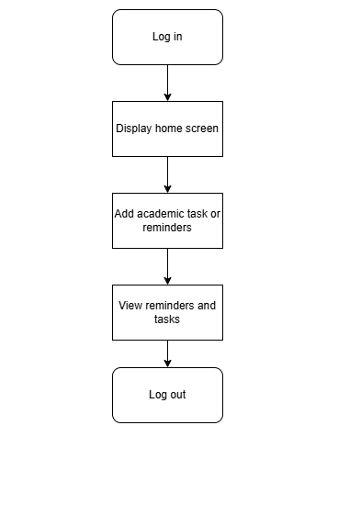

**Part C: Interface Sketching and Django Wireframe**

**Annotations:**

1. Visibility (Clear Priorities)
   * Calendar , Tasks , and Wellness ,icons are prominently placed at the top for quick access.
   * Task list is prioritized over other elements (larger font, centered).
2. Feedback (Interactive Elements)
   * Mood selector shows immediate visual feedback (e.g. highlights when selected).
   * Task checkboxes update with a checkmark when clicked.
3. Constraints (Guided Actions)
   * "Submit" button for mood check-in is disabled until a mood is selected (grayed out).
   * No delete option on the dashboard—users must navigate to a dedicated "Edit Tasks" screen.
4. Consistency (Uniform Design)
   * All buttons (e.g., "Add Task") use the same color/style.
   * Icons follow a standardized size and spacing.
5. Error Prevention
   * Tasks with approaching deadlines are highlighted in red.
   * Empty states (e.g., "No tasks due today") avoid confusion.

**GitHub link**

https://github.com/Tiisetso-githb/Tiisetso_HCI.git

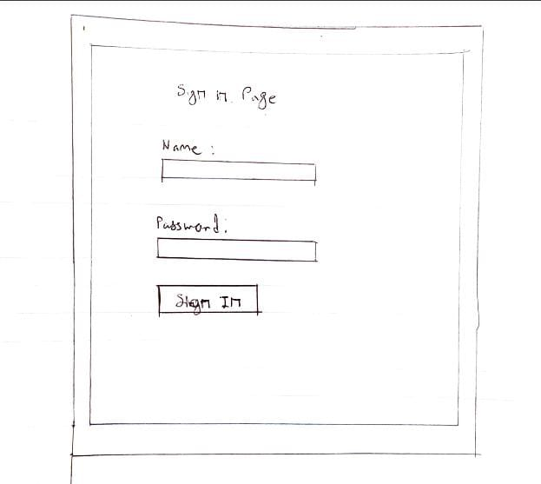**2.2**

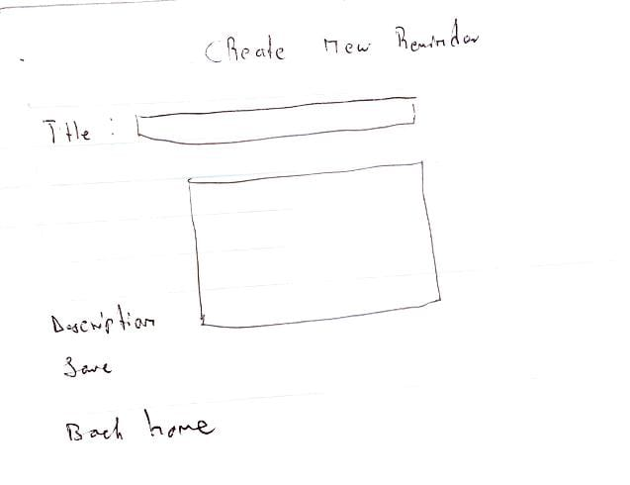

**Part D: Evaluation Plan**

**1. Usability & UX Goals**

**Usability Goals:**

1. **Efficiency:** Students can log a task or wellness check-in within **30 seconds** (measured via timed tasks).
2. **Learnability:** First-time users complete core workflows (e.g., adding a deadline) **without instructions** (measured via success rate).

**UX Goal:**

* **Empowerment:** Users report feeling **20% more in control** of their workload after one week (measured via pre/post-survey Likert scales).

**2. User Testing Questions**

1. "How intuitive was it to navigate between academic and wellness features?"
2. "Did the reminders feel helpful or intrusive? Why?"
3. "What additional information would you want on the dashboard?"
4. "How would you describe this app to a peer?" *(Tests metaphor clarity)*

**3. Evaluation Method: Think-Aloud Protocol**

**Procedure:**

* Recruit **5 students** (mix of personas from Part A).
* Give them **3 tasks**:
  + Add a mock assignment with a reminder.
  + Log stress during a simulated exam week.
  + Find counseling resources.
* Observe and record verbal feedback during tasks.

**Relevance:**

* Uncovers **hidden pain points** (e.g., confusing icons, jargon).
* Reveals **emotional responses** (frustration/relief) in real-time.
* Aligns with **UX goal** by assessing perceived control.

**Metrics to Record:**

* Time to complete tasks.
* Number of errors/clicks.
* Quotes like *"I expected the break button to be here..."*

**Part E: Reflection**

Completing this assignment deepened my understanding of user-centered designas an iterative process rather than a linear one. Initially, I assumed students would prioritize productivity over wellness, but interviews revealed their desire for integrated solutions—like break reminders tied to study sessions. This highlighted how UCD requires setting aside personal biases to address real user needs, not just assumed ones. For example, one interviewee’s frustration with "notification overload" led me to design context-aware alerts that adapt to their schedule—a nuance I’d overlooked in early sketches.

Conceptual modeling proved challenging in balancing simplicity with functionality. Creating a system that merged academic and wellness features risked becoming overly complex. My first diagram resembled a flowchart with dozens of nodes, but feedback reminded me to focus on core interactions (e.g., linking stress logs to schedule adjustments). I learned that a good conceptual model acts as a "translator" between user needs and technical systems—it must be detailed enough to guide development but flexible enough for iteration. The breakthrough came when I adopted the **"**Academic Companion" metaphor, which naturally unified both domains under a single mental model.

The sketching and Django wireframe phase revealed gaps between theory and practice. While paper prototypes helped visualize the UI, translating them into a functional wireframe exposed technical constraints. For instance, Django’s templating system initially limited dynamic updates for real-time progress tracking, pushing me to simplify the design. However, this constraint sparked creativity—I used Bootstrap’s progress bars to simulate milestone tracking without backend complexity. The process taught me that wireframes are communication tools; my annotated screenshots helped peers understand interactions that code alone couldn’t convey.

Moving forward, I’d invest more time in low-fidelity testing before coding. Early user feedback on paper prototypes could have identified navigation issues I later encountered in Django. This project underscored that UCD thrives on humility—each stage (research, modeling, prototyping) exposed flaws in my assumptions, but each revision brought the design closer to something truly student-centered. The biggest lesson? A perfect design doesn’t exist—only one that evolves with its users**.**